Finn Sullivan
Professor Lesley Lavery
Urban Politics
4/19/21
Zoning in Cambridge
Cambridge Massachusetts has a deep African American history full of firsts and conflicts. It elected the first Black, lesbian mayor of a major American city, and has a history of integrated private schools which existed long before Brown v Board of Eudcation (Cambridge Historical Comission). Yet despite these accomplishments the city also did much to help bring about zoning laws in Massachusetts and by extension, exclusionary zoning. The history of segregation and integration in Cambridge is at once both inspiring and depressing.
As with much of the United States, Cambridge struggles with full racial integration and citizen participation of African Americans and other communities of color. Much of the infrastructure in Boston and the surrounding cities has been problematic for communities of color, either threatening to directly displace them or ignoring their needs. The canceled Interstate 695/I-95 extension projects are prime examples of this history. The I-695 project would have served as an express route around an extended I-95 in order to save residents time (Propp). This came on top of proposals to extend Route 2 and I-95, both of which would affect Cambridge. It would have cut Cambridgeport, one of the best integrated neighborhoods in Cambridge, in half as well as destroyed the land of the Massachusetts Institute of Technology had it been built (Propp). This project, as well as the I-95 extension fell only as result of a herculean effort including the involvement of the Catholic Church, MIT lobbying heavily against the project and local alternative route proposals of Boston and Cambridge citizens to bring down the highway's construction against almost impossible odds (Kaiser, 2017). State planners finally canceled the project for good in 1970 (Kaiser, 2017). Despite bringing down the highway project, residents could not escape another force which would divide their neighborhoods; zoning.
Zoning, both in Cambridge and in the Commonwealth of Massachusetts, came about as a result of a successful amendment to the State Constitution in part thanks to advocacy by politicians from Cambridge in the General Court such as Robert Walcott at the 1918 constitutional convention (MacArthur, 2019). Massachusetts voters then approved amendment LX in the 1918 election (MacArthur, 2019). This amendment arguably is one of the most powerful tools which segregationists could use as a wedge against communities they viewed as “undesirable”. The simplicity of the amendment which gave cities and towns the power to limit to certain districts where various types of buildings could be constructed, hides immense power. Representative Kidder of Cambridge further cemented the city’s place in the troubled history of zoning by tabling a bill to bring the amendment into effect in 1920. Enabling legislation became law on June, 4th of the same year (MacArthur, 2019). The city would exercise its new power by adopting the first major zoning plan in 1924. The initial plan largely set height limits and designated districts as either, business, residential or industrial (MacArthur, 2019). However, height limits are not innocent architectural concerns solely about protecting the style of the neighborhood;they have real impact on density by preventing tall housing projects with more capacity. Height limits are not the real issue in creating segregation, they are only a fraction of many restrictions which a city is free to impose. These include minimum lot sizes, yard minimums, floor area ratio rules just to name a few major components of the contemporary rules in Cambridge zoning ordinance.
The Cambridge City Council responded to initial dissatisfaction with the zoning ordinance by adopting a new policy in 1943 which more closely resembles the modern laws. Indeed overlay maps show a disturbingly strong correlation between the 1943 zoning map and census tract level demographics. The 1943 plan incorporated citizen concerns by formally setting limits on neighborhood level density and further reducing the height limits of buildings, the 1943 used a similar system of height limits with the most permissive being R1 (100 feet), and the most restrictive being “Residential A” (35 feet) (MacArthur, 2019). Many districts were bumped down a tier in height limit as the maps below show in greater detail. For example many R1 areas were rezoned as “C2” which shaved off 35 feet from the maximum height of buildings. This downzoning was an enormous concession to many better residents of the most exclusive neighborhoods such as Brattle Street and was one of the key moments in shaping the modern day demographics of Cambridge. Although the ordinance was majorly reworked in 1962 and through a series of liberalizations between 1998 and 2000, the demographic scars still show today, particularly in neighborhoods with minimum lot sizes and height requirements that effectively rule out all but single family homes particularly in the residential A neighborhoods.
The city adopted further revisions to its zoning ordinance in 1962 by adopting floor area ratio requirements for each of the previously mentioned types of zoning districts (McArthur, 2019). Floor area ratio is another term for the ratio between the lot and floor area of the building. Limits on this tend to discourage multi-tenant projects in favor of buildings with a smaller footprint. According to the minutes of the planning board and publications in local newspapers at the time, limiting the number of families in any one building was one of the primary motivators for this proposal. The contents of the 1962 policy largely reflect how the city is zoned today with the exception of the previously mentioned 1998-2000 reforms which limited parking minimums, and allowed for residentials buildings in any part of the city (McArthur, 2019). Although there is not wide historical agreement on the exact reason for much of the downzoning, it is still of note that some of the areas given a more conservative zoning were more than 95% white and this may have been an effort to keep them that way.
A deeper drive into the data reveals some troubling insights although they are expected given the aforementioned history. Particularly relevant is the case of census data at the neighborhood level. Several neighborhoods are more than 80% white despite the city population being only about 68.1% white. Area 4 is 30.4% African American despite the city only being 11.9% African American, the MIT neighborhood is 37.8% Asian despite Asians only making up 12% of the city’s population (Cook, 2011). Furthermore, mirroring much of America, zoning has become inextricably tied to anti-blackness and the physical exclusion of black bodies from certain neighborhoods. Despite the history of zoning, Cambridge has made recent attempts to ameliorate the impacts of the 1943 and 1962 plans on African American Families. These efforts may well pay off in 1998 The neighborhoods themselves are decently integrated. As of the 2000 census, only one neighborhood was more than 86% white. No neighborhood was more than 31% African-American as of the 2000 census (Cook, 2011). Although establishing causality is rarely straightforward, there exists a relationship between how much an area’s zoning leans against multi-family homes and the percentage of minorities. While neighborhoods zoned at a less restrictive level than A resemble the city as a whole as of the 2017 American community survey, the population in areas zoned as residential A is more than 86% white (McArthur, 2019).
The story of segregation in Cambridge looks much like the nation as a whole on many levels. However, a couple of key policy breaks with much of America have led to noticeably better outcomes for African American Cantabrigians than compared to Massachusetts as a whole. Nevertheless, the question remains open “How did Cambridge hurt the rest of the state with its aggressive advocacy in favor of zoning laws in the Commonwealth?” Ultimately, Cambridge will still have to answer questions about its past to move forward. The ghosts of restrictive zoning still live on in neighborhood composition and in the zoning laws of the city. Indeed the delegate to the convention in 1918 from Wellesley who raised concerns about how zoning would affect African Americans was right that the amendment would “plainly authorize the segregation of the [African American]” (MacArthur, 2019) . It will take a fundamental paradigm shift and creative thinking to dismantle the old system entirely. The Conviction of Derek Chauvin for the murder of George Floyd may provide a long overdue nationwide reckoning given the renewed focus on raical justice, but that history is yet to be written. Zoning is a wicked problem with no inherently right solution. Residents on both sides of the debate raise legitimate concerns which there is no easy way to resolve all of.

Maps: All credit for the maps goes to Will MacArthur’s report cited below

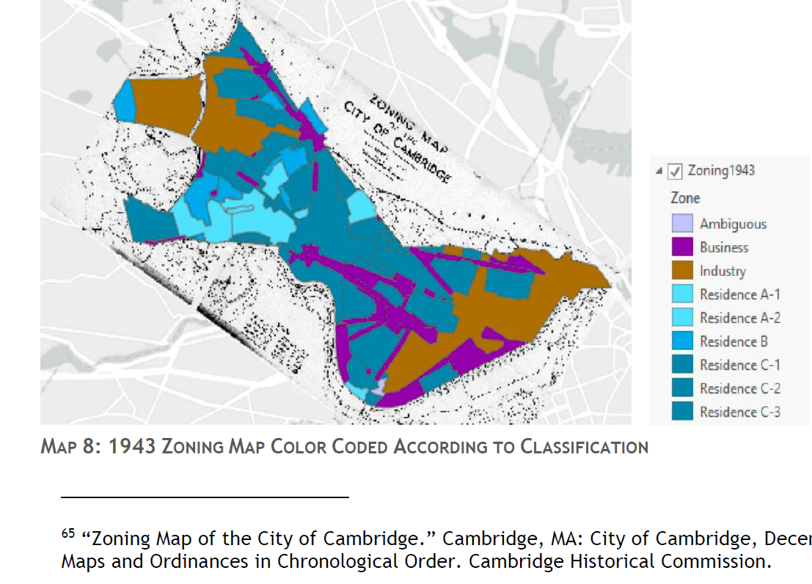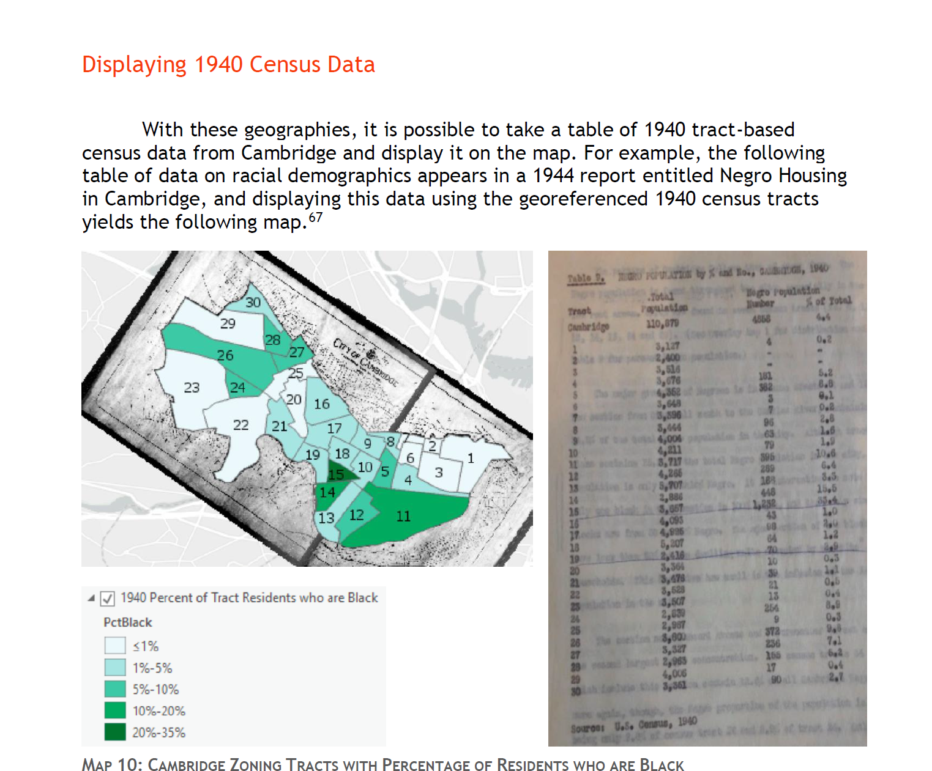

Sources
Berwick, C. (2018, October 26). 3 Promising Models of School Integration [Editorial]. Edutopia. Retrieved from https://www.edutopia.org/article/3-promising-models-school-integration
The Center for Voting and Democracy (2004, June). Center for voting and democracy. Retrieved April 22, 2021, from http://archive.fairvote.org/pr/cambridge.htm
City Of Cambridge. (2021, April 15). Cambridge is First City in New England to Launch Mayor-Championed Guaranteed Income Pilot Initiative for Single Caretaker Households [Press release]. Retrieved from https://www.cambridgema.gov/Departments/mayorsoffice/News/2021/04/guaranteedincomepilotinitiative
Cook, C. (2011, June). Citywide demographics. Retrieved April 21, 2021, from https://www.cambridgema.gov/CDD/factsandmaps/populationdata/citywidedemographics
Cambridge Historical Commission. (n.d.). Brief history of Cambridge, Mass. Retrieved April 21, 2021, from https://www.cambridgema.gov/historic/cambridgehistory
Kaiser, S. (2017). Citizen Opposition To The Inner Belt : The Story Of Why Cambridgeport Became The Most Effective Neighborhood In The Metropolitan Boston Area (pp. 1-73, Rep.). Cambridge, MA: N.P.
MacArthur, W. (2019). The Kind Of City Which is Desirable and Obtainable (pp. 1-42). Cambridge, MA: City of Cambridge.
Propp, G. (n.d.). Boston's Canceled Highways [Web Blog post]. Retrieved April 21, 2021, from http://www.bostonstreetcars.com/bostons-cancelled-highways.html
Sabido, K. (2021, March 22). Cambridge's BIPOC residents being vaccinated at a higher rate than state [Editorial]. Wicked Local. Retrieved April 21, 2021, from https://www.wickedlocal.com/story/cambridge-chronicle-tab/2021/03/22/cambridge-places-bipoc-residents-forefront-vaccination-efforts/4798977001/

This I95 project was later scrapped due to severring many Boston Neighborhoods but much of the right of way clearance had already taken place. See Propp for more information on the impact on Boston.
The formal name for the State Legislature

